**EM215 - NUMERICAL METHODS**

**LAB ASSIGNMENT 1 PART (iv)**

MADHUSHAN R.

E/17/194

SEMESTER 4

01.12.2020

$a = 0, b = 2.0$

1. 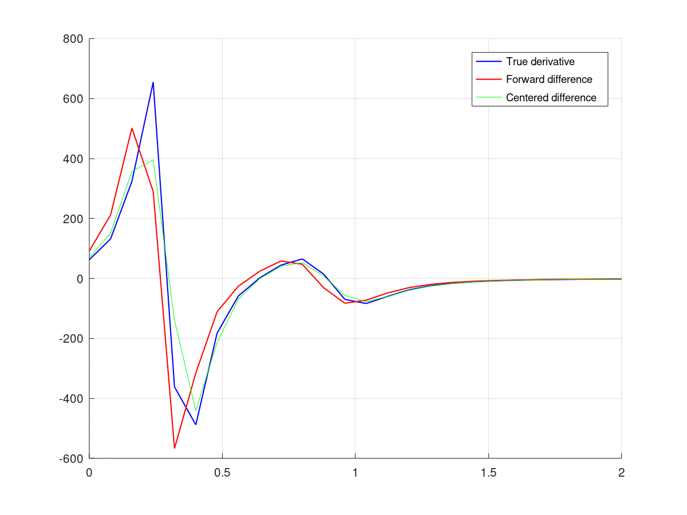a) when $h = 8×{10}^{-2}$

Have a big error

b) when $h = 8×{10}^{-3}$

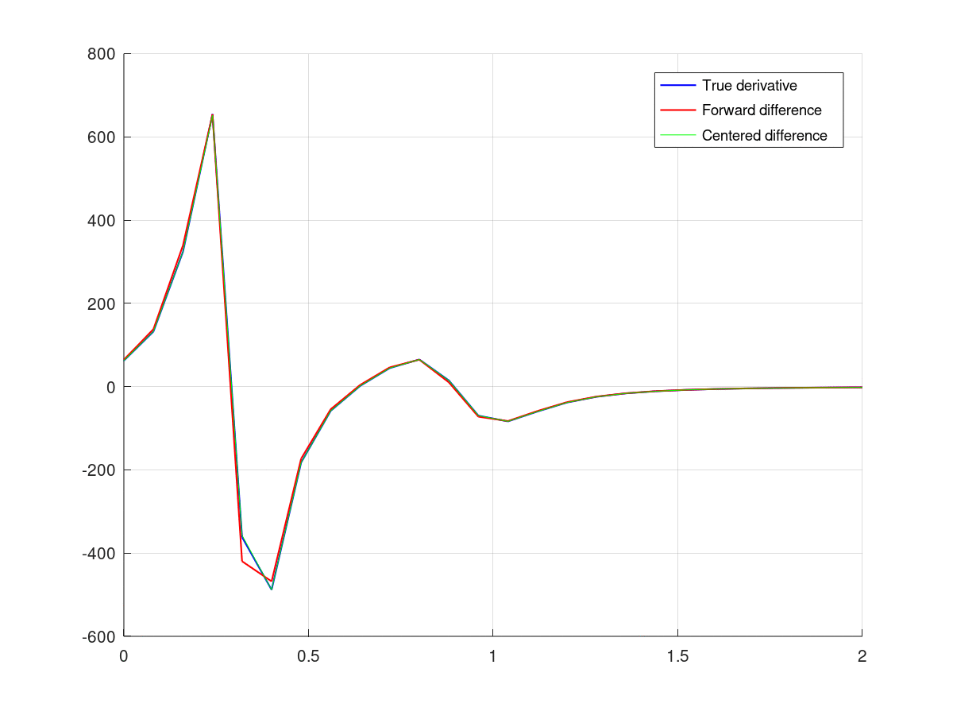

Comparatively less, but still have a considerable error

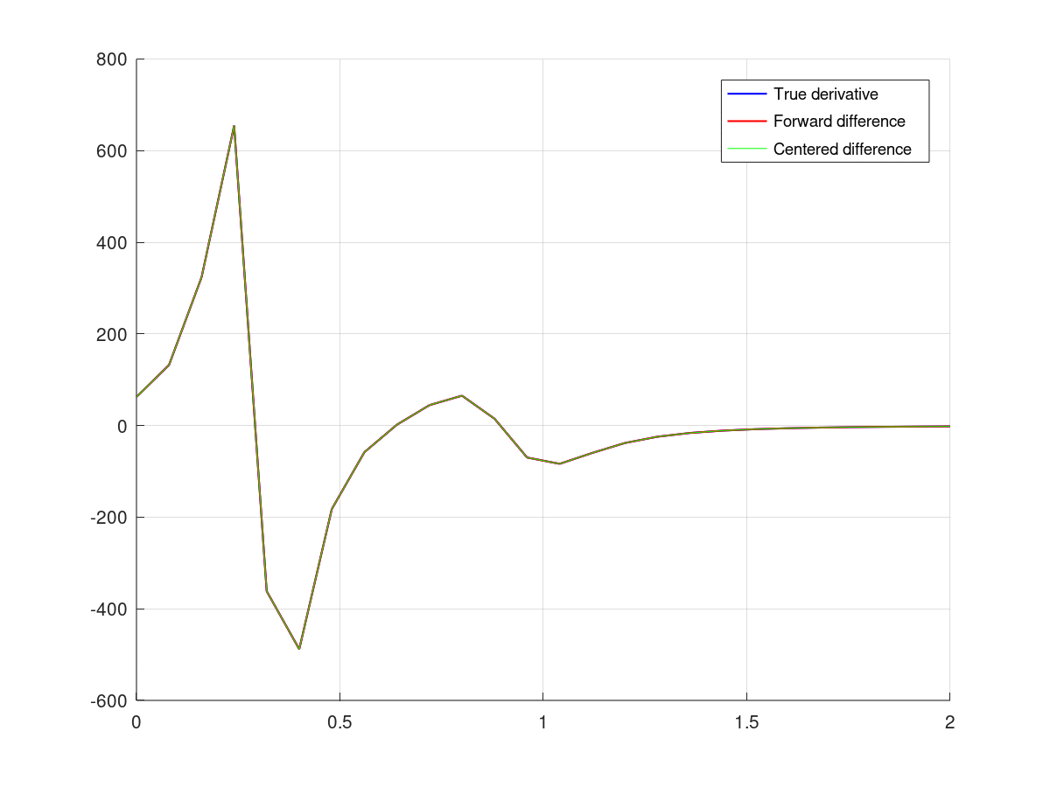c) when $h = 8×{10}^{-8}$

The estimation fits the actual derivative more

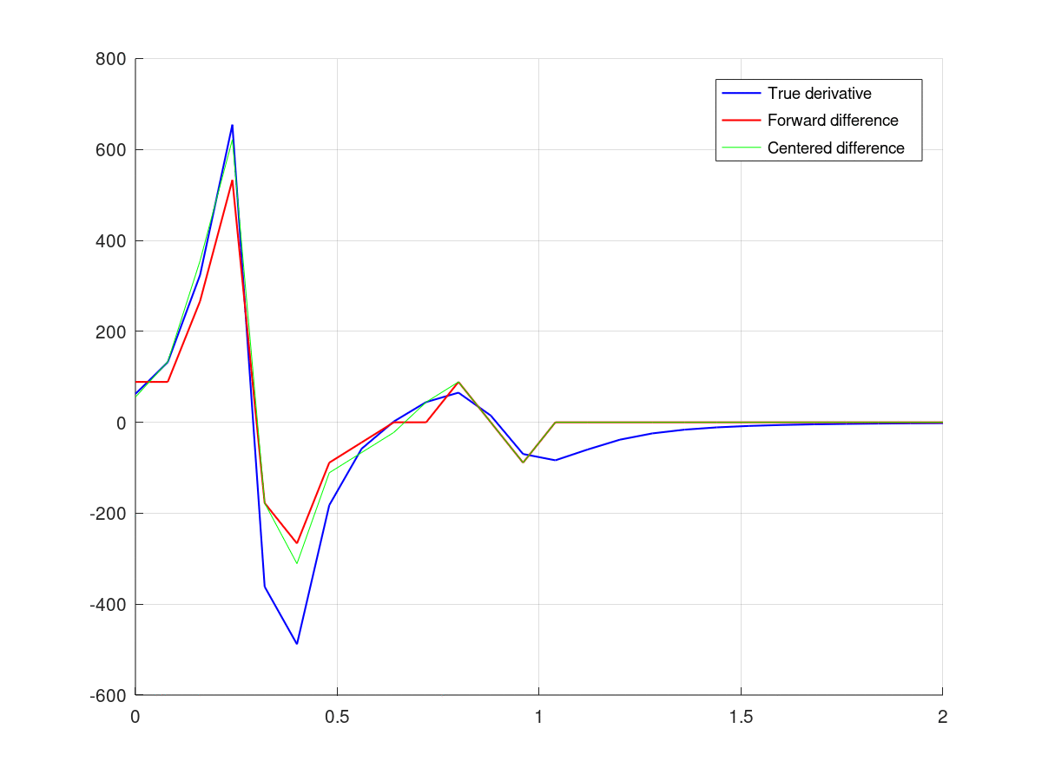d) when $h ≤ 8×{10}^{-17}$

Due to round off errors total error increases drastically

1. A new function to calculate the fourth order centered difference approximation of first derivative;

function yp4 = diff_center4 ( f_string, x, h )

%% diff_center uses centered differences to estimate f'(x).

f_element = vector_to_element ( f_string );

f = str2func ( [ '@(x)', f_element ] );

if ( nargin < 2 )

( ischar ( x ) )

x = str2num ( x );

end

if ( nargin < 3 )

( ischar ( h ) )

h = str2num ( h );

end

n = length ( x );

yp4 = zeros ( n, 1 );

for i = 1 : n

%formula for fourth order centered difference

yp4(i) = ( - f ( x(i) + 2*h ) + 8*f ( x(i) + h ) - 8*f ( x(i) - h ) + f ( x(i) - 2*h ) ) / 12.0 / h;

end

return

end

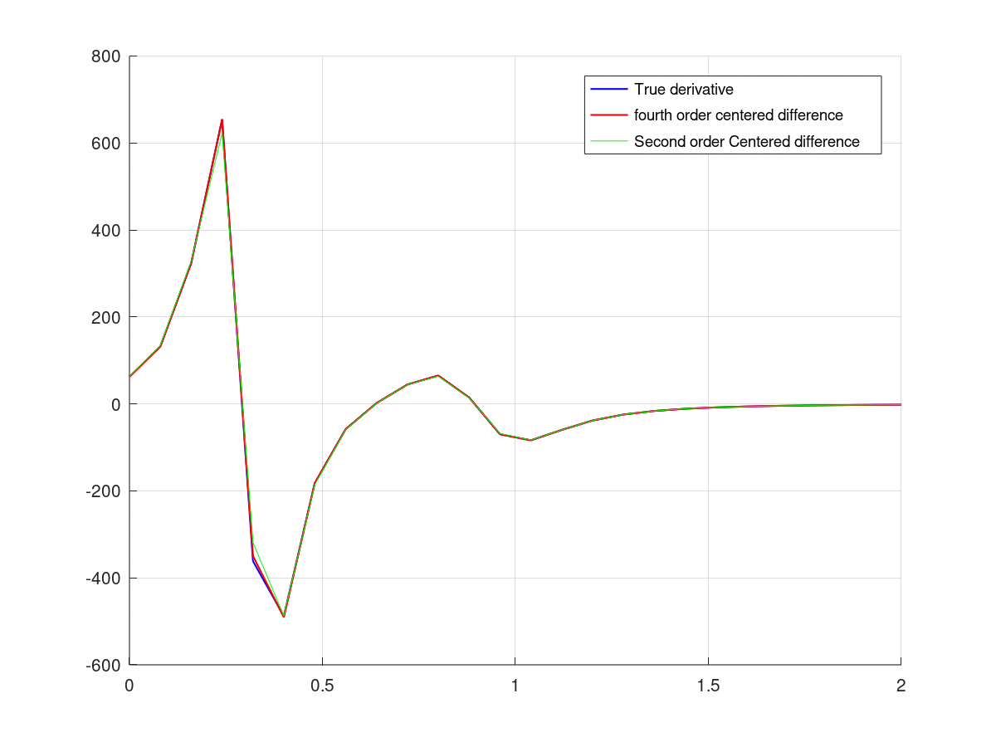for $h ≈{2.67×10}^{-2}$





Fourth order centered difference has lower error than second order centered difference.

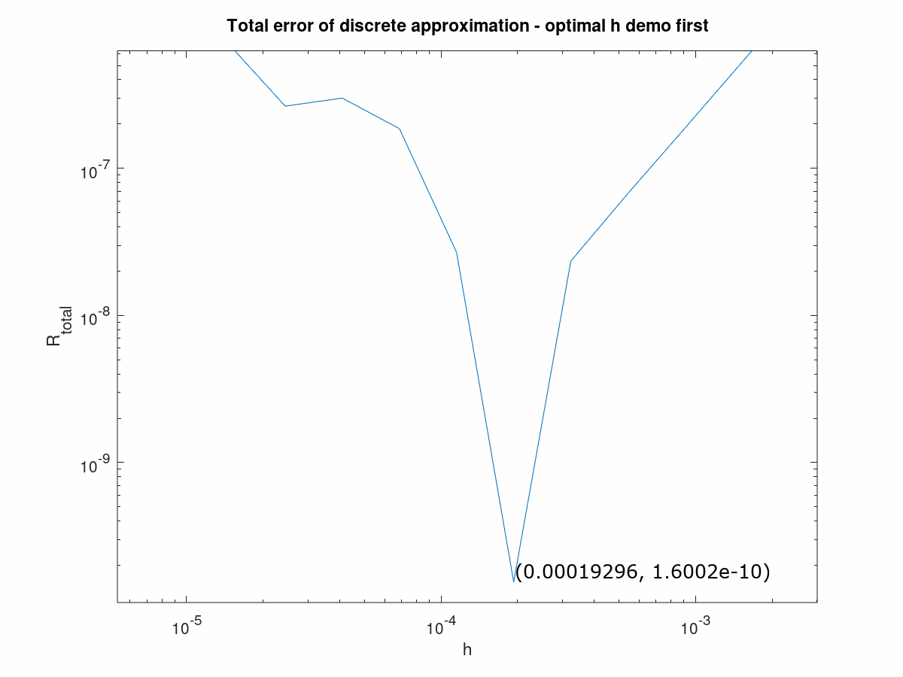

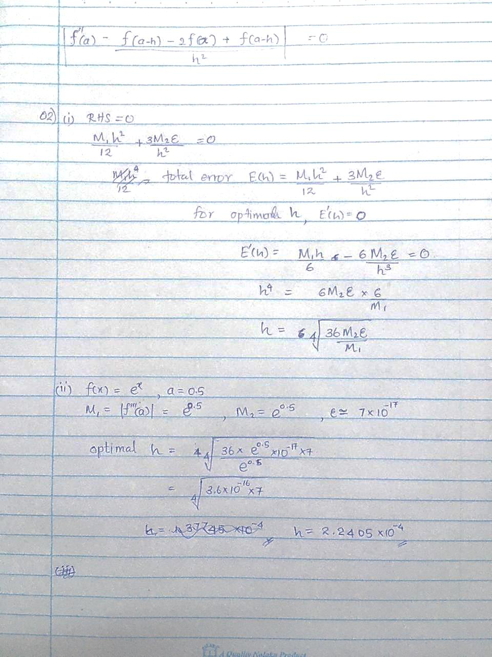

(Image above is zoomed for the minima)

Theoretically optimal $h=2.2405×{10}^{-4}$

Numerically optimal $h=1.9296×{10}^{-4}$